CUB SCOUT PINEWOOD DERBY

I. Requirements
A. Equipment
1. Cub Scout Owned
a. Methodist Church
(1) Flags and stands – room 307
(2) Public address system – room 602, top shelf far right-hand corner
b. Dana Duckett’s Farm, 24281 X Avenue, Grimes, IA 50131
(1) Pinewood derby track (x pieces)
(2) Tubs:
(a) Electronic scoring
(b) 2 – Scales
(c) Extra pinewood derby parts
c. Computer (Mr. Fox)
d. Projector (Mr. Fox)
e. Cordless microphone (Mr. Fox)
2. Procured by Pack for Event
a. Pinewood derby car kits for each Scout.
b. Paper plates
c. Black Sharpie markers
d. 2 – Bottles of Crazy Glue
e. Adhesive weights
f Caution tape
g. Painter’s tab (affix wiring to track)
h. Trophies (from Crown Trophies in Grimes, IA
(1) Place trophies
(a) First through fourth, Pack
(b) First through fourth, each Den
(2) Judge category trophies
(a) Least Aerodynamic
(b) Best Paint Job
(c) Best Scout Effort
(d) Best Scout Spirit
(e) Most Realistic
(f) Most Creative
(g) Cub Master’s Choice
(h) Most Patriotic
(3) Participation trophies (everyone who did not earn a trophy)
i. Neck ribbons for Open Class participants
3. Solicited from Leadership/Parents for Event
a. 2 – Hammers
b. 2 – Drills, cordless preferred
c. 2 – Needle-nose pliers
d. 1 – Screwdriver set (Phillips’s and Straight)
e. 4 – Extension cords
f. 4 – 3-way converters or surge protectors
4. Facility
a. 7 – Tables (5 – pinewood derby, 2 – concessions)
b. 8 – Folding chairs (4 – on deck, 4 – racers, 2 – announcer/computer operator)
B. Personnel
1. Car check-in (night before race)
a. Computer operator
b. 2 – Car check-in, inspection
c. 4 – Track setup
2. Race day
a. Computer operator
b. Announcer
c. On-deck monitor
d. 2 – Track car loaders
e. 2 – Track car unloaders
f. Repairer
g. 2 – Judges
h. 2 – Concessions (if allowed)
II. Procedures
A. Room setup – See DERBY LAYOUT.
B. Track setup (TBD).
C. Car check-in.
1. Weight the car wheels up - 5 oz (add adhesive weight to those low or drill out for those high)
2. Gauge location of axles
3.. Enter the car into the race software.
4. Mark the car with the entry number (bottom or back).
5. Mark a paper plate with the entry number and place the car on the paper plate.
5. Place cars on Pack Car or Open Class Car Table, as appropriate.
D. Repair table preparation.
1. Tools
2. Extra tires and axles
E. Announcer table preparation.
1. Place the American Flag as viewed from the stands to the left of the table and the Cub Scout flag to the right of the table.
2. Set up the public address system to the right of the table as viewed from the stands and connect the cordless microphone.
3. Set up the computer to the left of the table as viewed from the stands and connect the projector with the projection on the wall to the rear of the table.
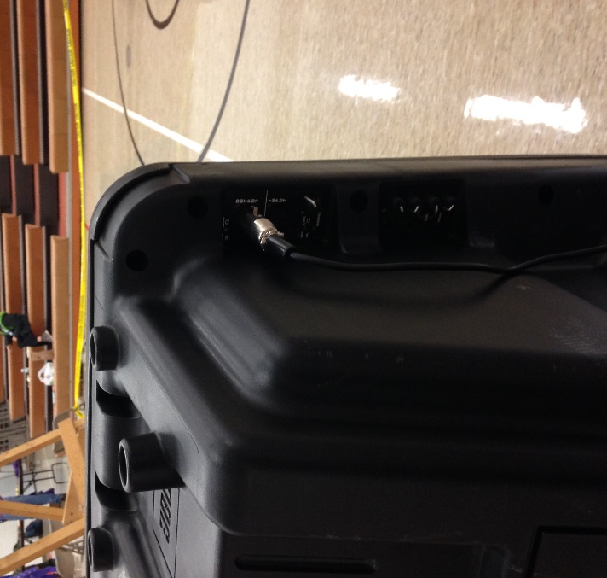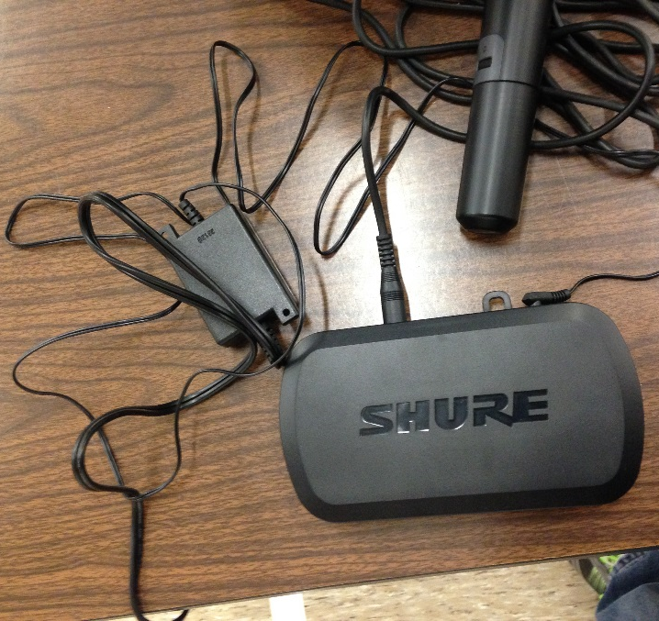
F. Race Day – General.
1. Pledge of Allegiance.
2. Explanation of race procedures.
3. Cub Scout pinewood derby races.
4. Cub Scout skit.
5. Open Class pinewood derby races.
6. Cub Scout skit.
7. Trophy presentation.
8. Close.
G. Race.
1. The Announcer will call the four entrants for the next heat.
2. Scouts will go to the car table, recover their car and go to the On-deck Chairs until their race.
3. The Scout will take their car to the Cr Loader who will load the car on the track and the Scout will move to the Racers chairs.
4. At the instruction of the Announcer, the Derby Starter will press a button to release all the cars simultaneously.
5. The computer automatically scores the placement of racers.
6. The Car Unloaders will remove the cars from the track and give the cars to the Scout to take back to the car table.
III. Timeline
A. Three months prior – reserve South Prairie Gym.
B. December Pack Meeting. Announce pinewood derby, provide car kits, and provide handout.
C. January.
1. Coordinate with Mr. Duckett for track pickup and visit to validate availability of equipment:
a. Track pieces are present and serviceable.
b. Electronic scoring equipment.
c. Tubs and associated expendables.
2. Validate South Prairie gym reservation.
3. Request volunteers for equipment and Derby duties.
4. Remind of event at the Pack Meeting.
5. Send out a reminder of the Pinewood Derby via e-mail and include a copy of the December handout.
6. Order trophies.
E. February.
1. Validate plan, roster of volunteers and responsibilities of equipment at Pack Leader Meeting.
2. Week of race.
a. Pickup trophies and medals.
b. Pickup tracks, tubs, public address system and flags.
c. Send reminder via e-mail of check-in.

DERBY LAYOUT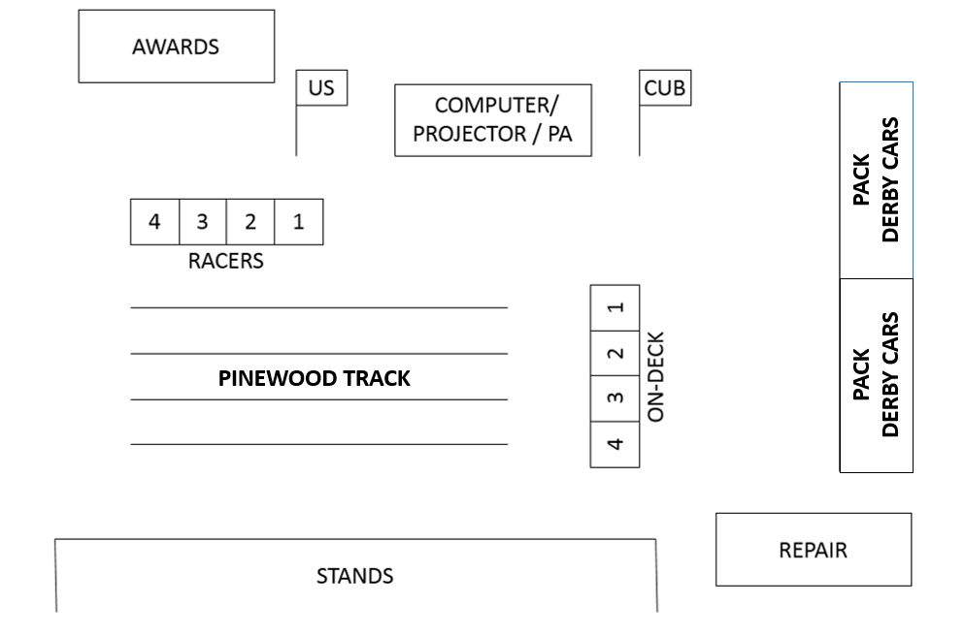

PINEWOOD DERBY

(http://www.grimesbsa.com/resources/activities/pinewood-derby/)

CHECK-IN: Car check in 4 March 7:00 pm - 8: 30 pm

PINEWOOD DERBY: 5 March 9:00 am - 12:00 pm

SPECIFICATIONS:
- Car size shall not exceed:
  - Width 2 3/4″ (including the wheels)
  - 1 3/4″ (where the wheels contact the body)
  - Length 7″ (some blocks are longer)
- Axle location cannot be altered (Note: You can however square up the grooves if necessary to make the car run straight.) All cars will be placed on an official BSA template to verify axle location the night of check-in.
- Car weight shall not exceed: 5.00 ounces
- The car must have at least 3/8″ under-clearance from the wheel rolling surface to the bottom of the car (between the wheels).
- Axles, wheels and body must be from the materials provided in the official BSA pinewood derby car kit. No Exceptions!
- Additional trim items are allowed as long total weight doesn’t exceed maximum weight and size.
- Wheel bearings, bushings and washers are not permitted.
- The car may not ride on springs or other suspension.
- The car must be freewheeling and gravity powered. No auxiliary form of propulsion is allowed including motors, rubber bands, rockets or magnetic devices.
- No loose materials (weights, characters or trim) are permitted. Fasten all securely.
- Do not alter the wheel shape or profile. You may eliminate burrs and molding marks.

TROPHY CATEGORIES
- 1-4 Place in the overall Pack
- 1-4 Place in each Den
- 8 Award categories in overall Pack:
  - Best paint job
  - Best scout spirit
  - Best scout effort
  - Least aero-dynamic
  - Most realistic
  - Most creative
  - Cubmaster’s choice
  - Most patriotic

PINEWOOD DERBY

(http://www.grimesbsa.com/resources/activities/pinewood-derby/)

CHECK-IN: Car check in 4 March 7:00 pm - 8: 30 pm

PINEWOOD DERBY: 5 March 9:00 am - 12:00 pm

SPECIFICATIONS:
- Car size shall not exceed:
  - Width 2 3/4″ (including the wheels)
  - 1 3/4″ (where the wheels contact the body)
  - Length 7″ (some blocks are longer)
- Axle location cannot be altered (Note: You can however squareup the grooves if necessary to make the car run straight.) All cars will be placed on an official BSA template to verify axle location the night of check-in.
- Car weight shall not exceed: 5.00 ounces
- The car must have at least 3/8″ under-clearance from the wheel rolling surface to the bottom of the car (between the wheels).
- Axles, wheels and body must be from the materials provided in the official BSA pinewood derby car kit. No Exceptions!
- Additional trim items are allowed as long total weight doesn’t exceed maximum weight and size.
- Wheel bearings, bushings and washers are not permitted.
- The car may not ride on springs or other suspension.
- The car must be freewheeling and gravity powered. No auxiliary form of propulsion is allowed including motors, rubber bands, rockets or magnetic devices.
- No loose materials (weights, characters or trim) are permitted. Fasten all securely.
- Do not alter the wheel shape or profile. You may eliminate burrs and molding marks.

TROPHY CATEGORIES
- 1-4 Place in the overall Pack
- 1-4 Place in each Den
- 8 Award categories in overall Pack:
  - Best paint job
  - Best scout spirit
  - Best scout effort

  - Least aero-dynamic
  - Most realistic
  - Most creative
  - Cubmaster’s choice
  - Most patriotic

