CUB SCOUT ROCKET DERBY

I. Requirements
A. Equipment
1. Cub Scout Owned
a. Methodist Church
(1) Flags and stands – room 307
(2) Public address system – room 602, top shelf far right-hand corner
b. Dana Duckett’s Farm, 24281 X Avenue, Grimes, IA 50131
(1) Rocket derby track (3 pieces)
(2) 2 – Sandbags
(3) Tubs, includes, but not limited to following:
(a) 4 – Rocket carriers
(b) 4 – Foam bumpers
(c) 30 lb Fishing line
(d) 4 – Winders
(e) Rubber band hooks
c. Computer (Location?)
d. Projector (Location?)
e. Cordless microphone (Location?)
2. Procured by Pack for Event
a. 4 – Boxes rubber bands with oil
b. Glycerin
c. Paper plates
d. Black Sharpie markers
e. 2 – Bottles of Crazy Glue
f. 4 – Extra propeller systems
g. 4 – Extra dowels
h. Caution tape
i. Trophies
(1) Place trophies, first through forth
(2) Judge category trophies
(a) Least Aerodynamic
(b) Best Paint Job
(c) Best Scout Effort
(d) Best Scout Spirit
(e) Most Realistic
(f) Most Creative
(g) Cub Master’s Choice
(h) Most Patriotic
j. Participation ribbons
3. Solicited from Leadership/Parents for Event
a. 8 – Quick clamps (affix winders to table)
b. 4 – Drills, cordless preferred
c. 2 – Needle-nose pliers
d. 2 – Round files
e. 2 – Wire cutters
f. 1 – Phillips screwdriver (to affix starter piece to track frame)
g. 2 – Sandbags
h. 4 – Extension cords
i. 4 – 3-way converters or surge protectors
4. Facility
a. 9 – Tables (7 – rocket derby, 2 – concessions)
b. 8 – Folding chairs (4 – on deck, 4 – racers)
B. Personnel
1. Rocket check-in (night before race)
a. Computer operator
b. Rocket check-in, inspection
c. 2 – Track setup
2. Race day
a. Computer operator
b. Announcer
c. 4 – Winders
d. On-deck monitor
e. 2 – Track rocket loaders
f. 2 – Track rocket unloaders
g. Repairer
h. Judge
i. 2 – Concessions (if allowed)
II. Procedures
A. Room setup – See DERBY LAYOUT.
B. Track setup (Used distance between red lines at South Prairie gym for length.)
1. Set up start point end (spring on leg).
a. Spread legs and lock in cross bars, eye bolts in direction of track run, spring towards back of track.
b. Place two sandbags over bar across the rear legs of the start point frame.
c. Unscrew phillips screws on each side/top of forward leg.
d. Place starter lever over start point with vertical prongs up and horizontal prongs pointed in direction of track.
e. Screw the starter lever into frame with phillips screws.
2. Set up end point.
a. Spread legs and lock in cross bars, eye bolts in direction of track run.
b. Place two sandbags over bar across the rear legs of the end point frame.
3. Run track lanes.
a. For each of the four lanes, run 30# fishing line, knotting at the respective eye bolts, from start point to end point, cutting off any excess line from the knot.
b. Install rocket carriers on each line at the start point.
c. Install foam bumpers on each line at the end point.
4. Run caution tape on the perimeter of the track.
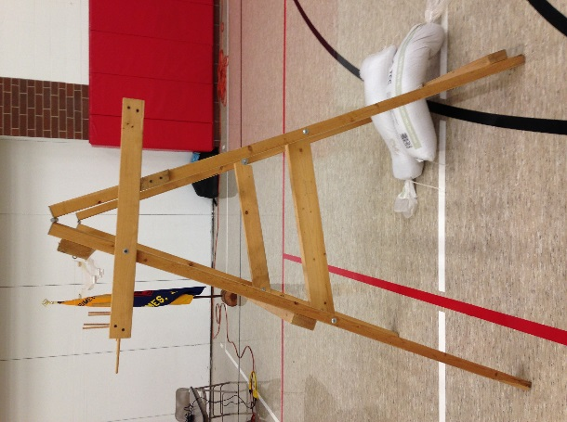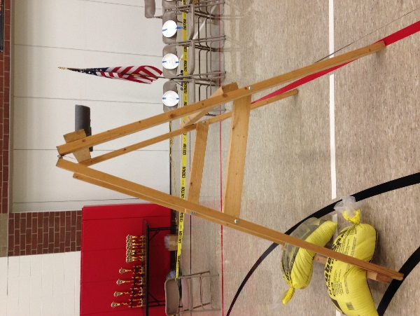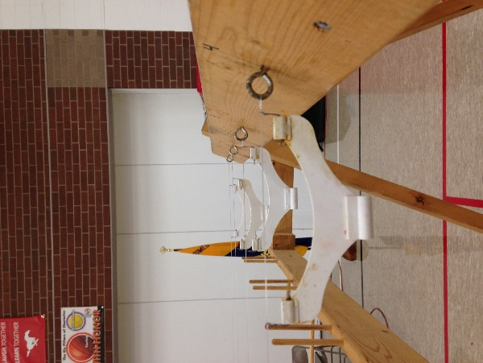
5. Prepare track for run on day of derby.
a. Pull start and end frames further apart on morning of race to account for stretching overnight.
b. Grease the fishing line with rubber band oil.
C. Rocket check-in.
1. Check the rocket for problem areas. (See Rocket Entrant Common Issues.)
a. Identify issues to Scout/parents.
b. Parent and scout correct issues.
2. Enter the rocket into the race software.
3. Mark the hanger with the entry number.
4. Mark a paper plate with the entry number and place the rocket on the paper plate.
5. Remove the rocket propeller system from the entry and discard rubber bands.
6. Place rockets on Pack Rocket or Open Class Rocket Table, as appropriate.
D. Rubber band preparation. (Night before race.)
1. Place all rubber bands in plastic zip lock bag.
2. Poor bottle of glycerin in plastic bag and ensure that rubber bands are soaked in glycerin.
E. Rocket preparation race day.
1. Take two rubber bands from the plastic rubber band bag.
2. Install rubber bands in rocket.
F. Repair table preparation.
1. Prepare four propeller systems with glycerin rubber bands for quick installation.
2. Have super glue and tools available for preparation.
G. Winders table preparation.
1. Place winders at the four corners of the winder table and clamp each winder to the table with two quick clamps.
2. Connect drills to winders.
H. Announcer table preparation.
1. Place the American Flag as viewed from the stands to the left of the table and the Cub Scout flag to the right of the table.
2. Set up the public address system to the right of the table as viewed from the stands and connect the cordless microphone.
3. Set up the computer to the left of the table as viewed from the stands and connect the projector with the projection on the wall to the rear of the table.
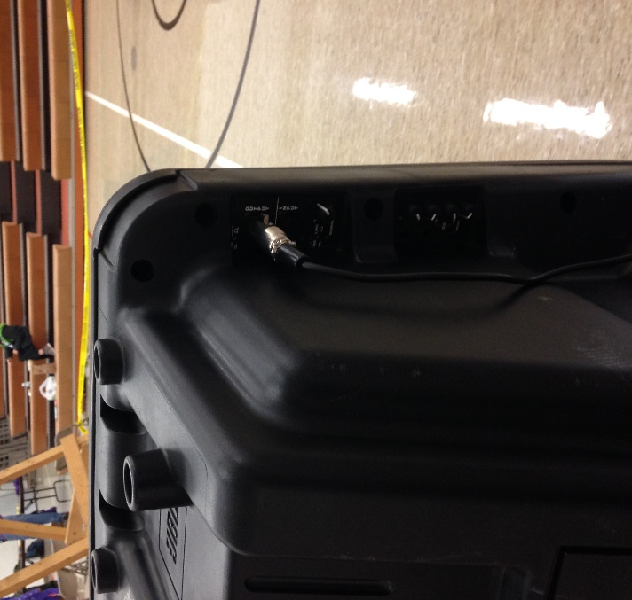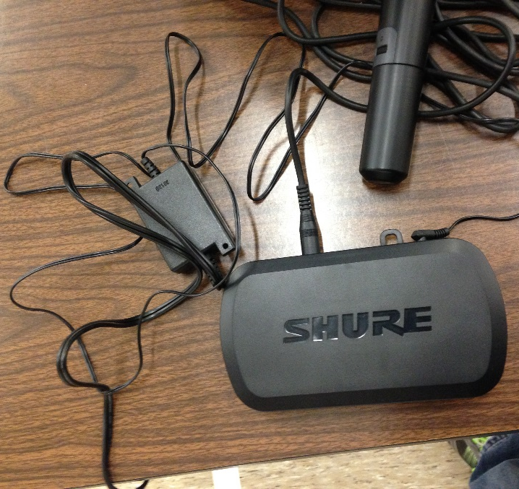
I. Race Day – General.
1. Pledge of Allegiance.
2. Explanation of race procedures.
3. Cub Scout rocket derby races.
4. Cub Scout skit.
5. Open Class rocket derby races.
6. Cub Scout skit.
7. Trophy presentation.
8. Close.
J. Race.
1. The Announcer will call the four entrants for the next heat.
2. Scouts will go to the rocket table, recover their rocket table and go to the winder table.
3. The Scout will hold the rocket as the rocket is wound and then hold the propeller when complete.
4. The Scout will wait at the On-deck Chairs until their race.
5. The Scout will take their rocket to the Rocket Loader who will mount the rocket on the rocket hanger with the propeller locked on the rocket lever. The Scout will move to the Racers chairs.
6. At the instruction of the Announcer, a Rocket Loader will lift the starter lever from the back of the track to run the race.
7. The Rocket Unloader will observe the results of the race and relate to the computer operator.
8. The Rocket Unloader will remove the rockets from the hanger and give the rockets to the Scout to take back to the rocket table. (Be sure that the Scouts have the dowel with their rockets.)
9. The Rocket Unloader sends the rocket carrier back to the start on the fishing line.
III. Timeline
A. Three months prior – reserve South Prairie Gym.
B. September Pack Meeting. Announce rocket derby and provide handout with details on front and Rocket Entrant Common Issues on back.
C. October.
1. Coordinate with Mr. Duckett for track pickup and visit to validate availability of equipment:
a. Rocket carriers.
b. Winders are present and serviceable.
c. Foam bumpers.
d. Track pieces are present and serviceable.
e. Fishing line.
f. Wire hooks to thread propeller rubber band systems in rockets.
2. Validate South Prairie gym reservation.
3. Request volunteers for equipment and Derby duties.
4. Remind of event at the Pack Meeting.
5. Send out a reminder of the Rocket Derby via e-mail and include a copy of the September handout.
6. Order trophies.
D. November.
1. Validate plan, roster of volunteers and responsibilities of equipment at Pack Leader Meeting.
2. Week of race.
a. Pickup trophies and ribbons.
b. Procure rubber bands and glycerin.
c. Pickup tracks, tubs, public address system and flags.
d. Send reminder via e-mail of check-in.

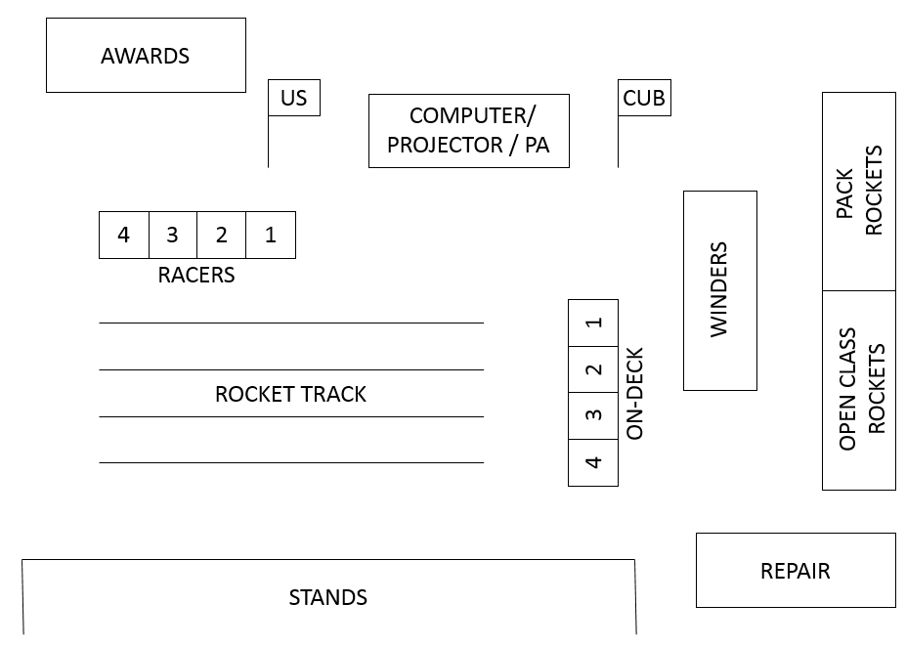
DERBY LAYOUT

ROCKET ENTRANT COMMON ISSUES

Propeller flat end toward bushing
Hanger not centered;
Hanger not glued in
No notch in tail for dowel
Propeller assembly glued to rocket nose

ROCKET DERBY HANDOUT

Cub Scout Pack 171 will conduct the annual rocket derby, the second Saturday of November at the South Prairie Elementary gym that will also serve as the Pack Meeting for the month.

The rocket derby is not only for Scouts, but family members may also participate in an open class race that occurs immediately following the races for the Scouts.

The Pack does not provide rocket kits. Rocket kits are available for purchase at the Scout Shop at the Maytag Scout Center, 6123 Scout Trail, Des Moines, IA 50321 or ordered online at http://www.scoutstuff.org/space-derby-kit.html.

Kits come with detailed instruction, but parents for new Scouts might appreciate the instructional video at https://www.youtube.com/watch?v=QFQ-Joc6Fo8.

Experience has shown that potato peelers are effective in shaping the glued rocket body followed by finishing sanding.

It is not necessary to thread rubber bands in the rockets. The Pack will thread new rubber bands in the rockets from the same lot to assure consistency in rubber bands for all participants.

Check in for rockets will be on Friday the night before the race.

The Rocket Derby will begin at 0900 with an estimated noon time of completion.

Trophies will be awarded to the Scouts for First through Fourth Place and in the following categories:
- Least Aerodynamic
- Best Paint Job
- Best Scout Effort
- Best Scout Spirit
- Most Realistic
- Most Creative
- Cub Master’s Choice
- Most Patriotic

All participants will at least receive a participation ribbon.

The Scouts host a concession stand for the event. Assistance is needed in staffing the stand and donations of hot dogs, buns, cookies, chips, and beverages are appreciated to sell for the benefit of the Food Pantry.

If you have any questions regarding this event, e-mail XXXXXX.

